Optimal : first stored the last index and calculated the max distance in second loop 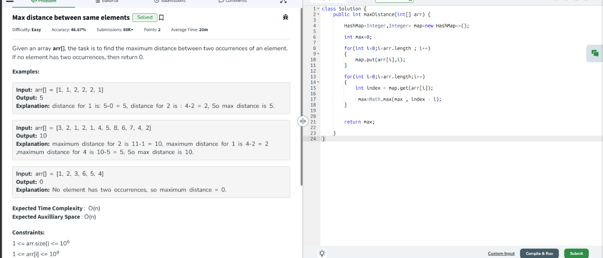

Brute force :
